**Data Modelling using ER-Model**

***Before starting something new , something which you don’t know about - ‘alien thing’ and wanna master that topic/concept. As an engineer , you should always ask questions. Atleast , you should ask Why , How , Which ?***

***These are the 3 questions I always ask the engineers I work with. Knowing the answer to these 3 means they are more likely to be engaged, show more initiative, and have greater understanding of the end goal. It helps guard against over/under architecting, prevents unnecessary work, and helps manage tech debt. It ensures that collaboration and knowledge sharing occurs in the planning stages.***



* **Introduction**

**Let us start with Why , Why do we use Data Modelling?**

*D*ata modelling is a technique to document a software system using diagrams and symbols. It is used to represent communication of data.

The highest level of abstraction for the data model is called the Entity Relationship Diagram (ERD). It is a graphical representation of data requirements for a database.

**Now how ! How can we Model our Data?**

An Entity Relationship (ER) Diagram is a type of flowchart that illustrates how “entities” such as people, objects or concepts relate to each other within a system. ER Diagrams are most often used to design or debug relational databases in the fields of software engineering, business information systems, education and research. ER diagrams also are often used in conjunction with data flow diagrams (DFDs), which map out the flow of information for processes or systems.

* **Important steps: -**



* **Conceptual Modelling -** 
* **ER-Model**

**-** High Level Data Model

* + **Entity**
    - * Real word Object
      * Independent Existence
      * Strong & Weak Entity
  + **Relationship** 
    - * A relationship type represents the association between entity types.
      * Types of relationships(Cardinality )
        + One to One
        + One to Many
        + Many to One

- Degree of Relationship

- Unary

- Binary

- Ternary

* + **Attributes**
    - * Characteristics of Data
      * Types of Attributes

Key Attributes

Composite Attributes

Derived Attributes

MultiValues Attributes

Complex Attribute

* **Participation Constraints** -
  + - * Total Participation
      * Partial Participation
* **How to Create on ER-Diagram**

* Entity Identification
* Relationship Identification
* Cardinality
* Identify Authentication

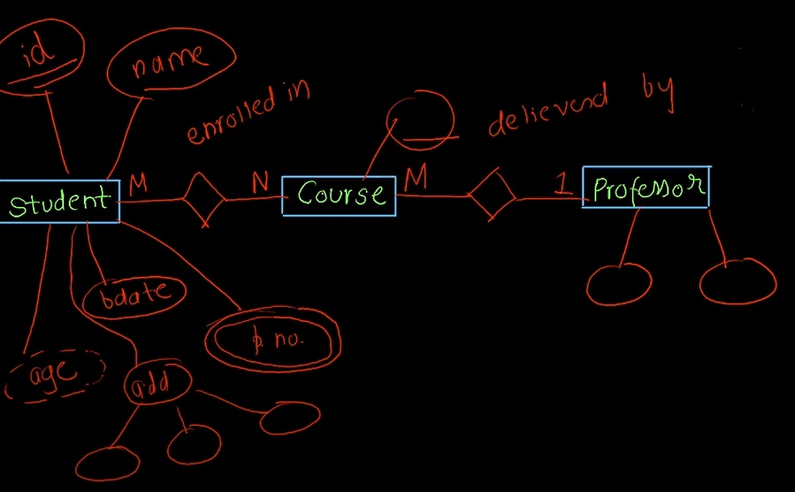

* **Symbols -**
* *Sign/Symbols used to represent ER-Diagram.*

